Part 1: Project Specification Document

# Project overview providing a summary of the proposed BI suite

Luhn 1958, defined business intelligence (BI) as *“the ability to apprehend the interrelationships of presented facts in such a way as to guide action towards a desired goal”*

Schemas, integration, storage, transformations, and workflow along with the data, define the data architecture and empower the analytical requirements of the intelligence architecture. Where the data is created through the source systems by intelligence providers and ends when the data analysis is performed is the setting for data architecture. The BI architecture consists of four technological layers.

* Data Sources: data captured by an organisation can be used
* Data Integration: can be made accessible by implementing tools to gather, integrate and transform data.
* Data Warehousing: A file or database that is used to supply data that is integrated can then be utilised by analytics and BI.
* BI and Analytics: an organisation can use these tools to disseminate and analyse data.

How do data integration, data warehousing, and BI all fit together? The aim of data integration is to deliver an integrated view that combines data from several sources and the elements include data sources; the processes and how the data is consolidated, transformed, and cleaned while also aggregating data and metadata. Therefore, if the organisation has inefficient data, it is most likely a data integration issue. Data warehousing is the storing of data that is detached from the organisations processing operations as it is converted into intelligence for the business consumers. After the data is summarised and placed in a repository the data is collected for analysis within the enterprise in a specific section, for example, the finance department. To gain knowledge this data is then presented to businesspeople, therefore, enabling the distribution of information. Reporting, Online Analytical Processing (OLAP) forecasting, statistics, decision support, and data mining are the main instruments for BI. It will then be visualised through dashboards where the data is acquired through relational data sources or enterprise applications such as Customer Resource Management (CRM) and Enterprise Resourcing Planning (ERP).

## Business Intelligence & Business Analytics Suite Decision:

Microsoft Dynamics 365 and Salesforce offer very similar functionality, it was decided to proceed with Microsoft Dynamics 365.

* The pricing appears to be more favorable
* AI is embedded within the system
* Many Microsoft solutions available to be integrated natively
* Developers can customize with Javascript.net and HTML

Microsoft Dynamics is a platform that offers a Technology Stack ‘cradle-to-the-grave’ solution to Business Intelligence and Business Analytics. The organization can implement the modules that will add the most value add to the business and scale up as and when required by adding further modules. Microsoft Power BI can be connected seamlessly, allowing endless visualization solutions. Due to the low code of Microsoft Power Platform, customization can be carried out by in-house developers. For organizations using Microsoft products, the recommendation is Dynamics 365 to allow for a smoother integration.

### Review of the Systems

As an SME, either Microsoft Dynamics 365 or Salesforce would be the optimal solutions. These need further exploration.

**Microsoft Dynamics 365**:

Microsoft Dynamics 365 is an all-encompassing end to end solution for any business to consider. Microsoft Dynamics 365 offers solutions in Sales, Finance, Supply Chain, Marketing, HR, etc.

The organization can pick the areas it needs to focus on most and begin by implementing these modules of Microsoft Dynamics 365, scale up by adding further modules as and when required.

Microsoft Dynamics 365 offers more customization with Sales & Service as cloud-based solutions, but other modules such as Finance and Operations are offered with on-premise versions, as an option [2]

Microsoft Dynamics 365 offers connections to Microsoft Power BI and PowerApps and is expanding its connections with the Microsoft AppSource. If the organization is already invested in Microsoft apps, then Dynamics 365 may be the preferred solution.

**Salesforce**:

Salesforce offers the same core functions as Microsoft Dynamics 365. Salesforce operates on a cloud CRM application, so data is stored on a remote server and uses browser-based software. Not ideal if the organization wishes to host the software on their own servers. For example, for I.P. reasons.

There are over 2,600 [2] apps on Salesforce Exchange and it also has its own partner program.

**Costing Considerations**:

The following cost comparison was obtained from cobalt.net [3]

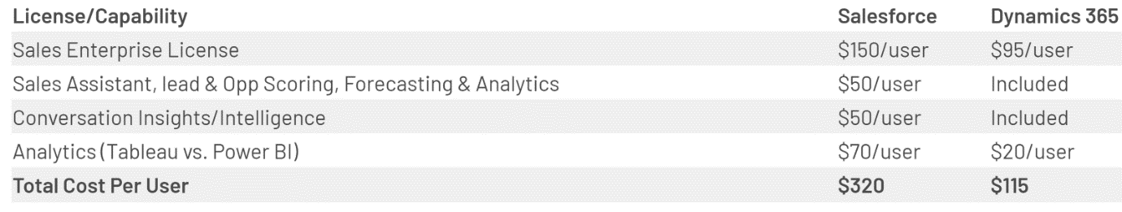

### Visualisation tools:

A review of the three systems was carried out using Gartner [1]. All three tools received high scores with Microsoft Power BI & Qlik Sense both scoring 4.4 out of 5, and Tableau coming in very close at 4.3 out of 5.  As the business has received the recommendation to implement Microsoft Dynamics 365, Microsoft Power BI would unquestionably be the visualization tool of choice. Whilst Tableau may offer more visualizations and ease of use, Microsoft Power BI is a more powerful tool. In this case, it is also more cost-efficient as it will integrate seamlessly with the selected Business Intelligence Suite, Dynamics 365. Tableau is a fundamental older platform than Power BI.

The most significant advantage of Power BI is that it can be incorporated into Dynamics 365. Aggregating data will save on integration costs as the information is stored in distinct systems within custom dashboards. Many enterprises experience situations where they have data located in different sources. For example, financial data is in the ERP application while customer data is in the CRM. Power BI can help negate this problem as it will ensure that intelligence is on demand. This will create better operations and deliver conclusions. This is one of the challenges company ABC has faced. By having access to real-time information, the sales process will be better managed by the CRM. Previously the data had to be acquired from several databases in a disposable format and required cleaning, by which time the intelligence had become dated. The main points we need to access are:

* Revenues
* Sales
* Products
* Customer

By integrating Power BI and 365 our company now has more efficient data that can be acquired in real-time. The company will now have aggregated data, and dashboards, and instead of having to gather data manually which led to stale information, it can be sourced on demand by management. This will create better visibility and increased output through better insights and more robust data.

# Project scope/objectives

Project Name: ABC Ltd Microsoft Dynamics 365 Implementation (CRM and Finance & Operations)

Project Team: Sinead Ryan, Kieran O’Hanlon

Scope & Objectives: The company currently does not have a centralized database of their customers, products, and financials. This project will aim to centralize all available data pertaining to customer master data, product master data, customer queries and the company’s financials.

The proposed Business Intelligence suite will aim to capture and store the data and make it readily available. The solution will enable management to easily visualise the required data as set out in the analytics requirements of the system design.

Note: The architecture of the system needs to be integrated to a secure IT infrastructure to guarantee all cyber-security and respective confidential information and data is not breached.

The scope of this project is to implement a Customer Relationship Management system and a Finance & Operations system. Microsoft BI will be implemented as the preferred visualization tool. All other modules of Microsoft Dynamics 365 are out of scope at this time but may be incorporated into a separate project in due course.

# Background

ABC Ltd. Is a relatively young company, having only being in operation since early 2018. It is a multi-channel retailer selling products in the home and garden sector. The channels that they operate in include, In-store, Online, Distributor and Wholesale.

ABC Ltd is a one-stop solution for all your home and lifestyle needs. They offer an extensive range of products both in-store and online. With 367 stores located across 48 states throughout the US, 28 sales reps, and 47 different products on offer, ABC Ltd has a lot of data to manage. They are looking to implement a CRM solution to enable swift resolution of customer queries and to maintain a complete database of their customers.

They need a ‘one-stop’ solution for the customer service team to access all relevant details about customers and related activities.

ABC Ltd is also keen to implement a Finance & Operations module. They want clearer visibility on revenues being generated by each sales stream, a snapshot of which sales members are generating the most revenue & sales quantity. And are also interested in their product margins to see which products are performing well.

It has been decided to implement Microsoft Dynamics 365 CRM module and Finance & Operations module at this point in time. ABC Ltd has the option to add further modules as and when required.

The organization is operating in a well-established market with several well know competitors. These include companies such as ‘The Range,’ ‘JSK,’ ‘Costco,’ and ‘Target’ to name but a few. One of the major issues facing the Home Furnishings Industry is Supply Chain Issues.

Another headline concern for all industries lies within customs/tariffs. With on ongoing ‘trade war’ between US and China, importers who continue to rely on supplies from China are facing ongoing import tariffs.

ABC Ltd is focused on protecting its margin, but also will need to remain mindful that they do not out price themselves against the competitor ‘Giants.’

# Strategy Map - Balance Scorecard

To strategize management systems and planning, enterprises use Balance Scorecards (BSCs). This will help the enterprise communicate objectives, align day-to-day operations, implement products, services, and projects, and examine and quantify strategic goals. The balanced scorecard offers a more balanced view of the organisation by aiming to move the focus away from short term financial growth alone, and instead incorporating the whole strategy map into the equation. The strategic scorecard is concerned with the organisations strategic goals so encompasses all categories.

The strategy map below shows how the business has organized its strategic objectives into the four categories:

Financial: drive financial growth by reducing costs and increasing profits.

Customer: improve customer satisfaction

Internal: the need to improve internal processes and efficiency

Learning & growth: The skills, knowledge, and systems that the organization needs to deliver the desired value.

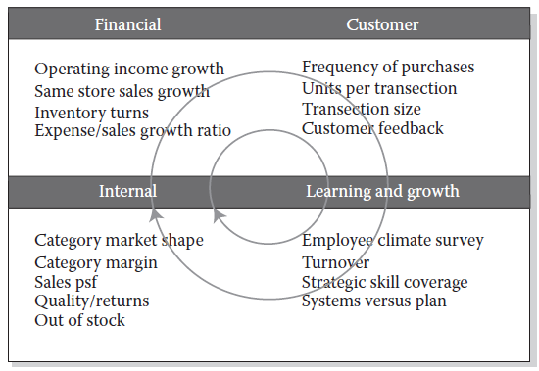

# System Design

Requirements gathering is possibly the most important aspect of any system design. It is imperative that requirements are clearly defined early in the design phase, for a successful implementation.

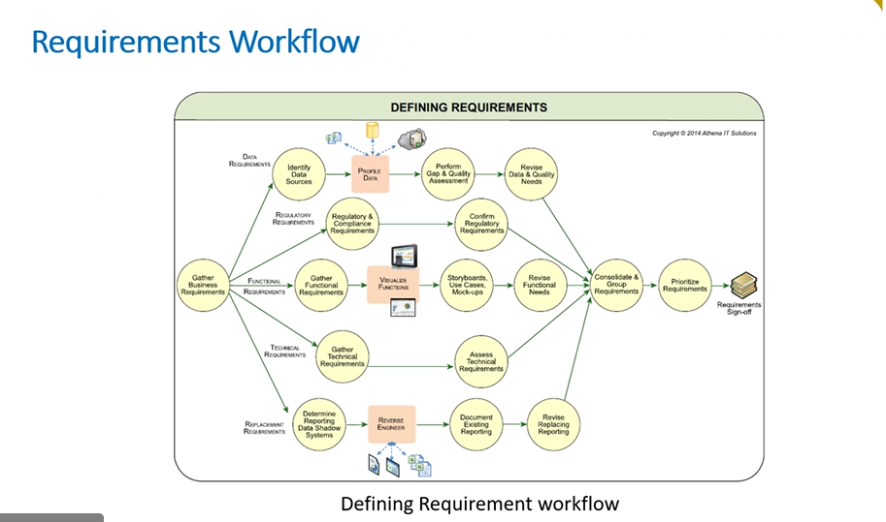

## Analytics Requirements

The analytics requirements stem from the business process and the key decisions that are dependent on the reports available. The company strategy includes maximising revenues & profits, monitoring customer activity and maintaining product margins.

ABC Ltd currently have a vast array of products and are unsure if all of these are (a) profitable to the company, and (b) products of interest to the customer.

ABC Ltd are particularly interested in setting up a dashboard view showing key metrics such as:

* Revenue by Region
* Profits by Sales Team
* Product margins
* Volume of sales by item

CRM: Implementing a Customer Relations Module in ABC Ltd will enable the company to view their customer database, see the conversion of leads to sales

Finance & Operations: Implementing a Finance & Operations module in ABC Ltd will enable the company to easier view their revenues, costs, profit & margins.

Power BI: Power BI will enable strategic dashboards to be created for the respective audience. These graphs and charts can be filtered and drilled into to allow for further analysis. The aim of the dashboards is to give senior management a quick, clear view of the key requirements/metrics.

## Functional Requirements

* Database Management
* Workflow Automation
* Lead Management
* Client Interaction Tracking
* Business Intelligence and Reporting
* Data Accessibility
* Data Integrity
* Generate actual revenue based on sales data
* Calculate product margins
* Product database

## Non-Functional Requirements

* Reliability
* Usability
* Performance
* Security
* Scalability

## Security Requirements

Lack of security requirements can lead to rework late in the project. Security is required due to sensitive data in the system such as business processes, customer data and financial information. It is imperative that this data is protected. The security model can be based using several tools:

* Business Units: framework to determine the organization structure. Users can be granted access based on the business unit they are assigned to.
* Security Roles: determines a user’s permission levels. Security roles can also be applied at a team level which enables privileges to be granted to a whole team rather than individual user.
* Hierarchy Security: manager hierarchy grants access based on the manager relationship and position hierarchy is based on a definable position.
* Field security: field level secured data, important when working with extremely secure data as specific details can be removed from view of users.

ABC LTD will use existing security roles within the suite.

## Data Capture

As all current data is on-premise, the data capture would be traditional including sources as SQL, excel, and SharePoint.

Looking to the future, moving company’s information to cloud-based solutions, then data lakes could potentially become the sources of data capture i.e., Azure.

The CRM module will capture customer data firstly when a lead is created. The customer service representative will log the client’s data as a lead. Once the lead moves through the pipeline it will be converted to an account.

The Finance module will allow for transactional tracking of all financial data. This will allow for trends on sales, calculations of profits and other relevant financial ratios as required for the company’s KPI’s.

Power BI – in a live production environment data can be obtained directly from Dynamics 365 as follows:

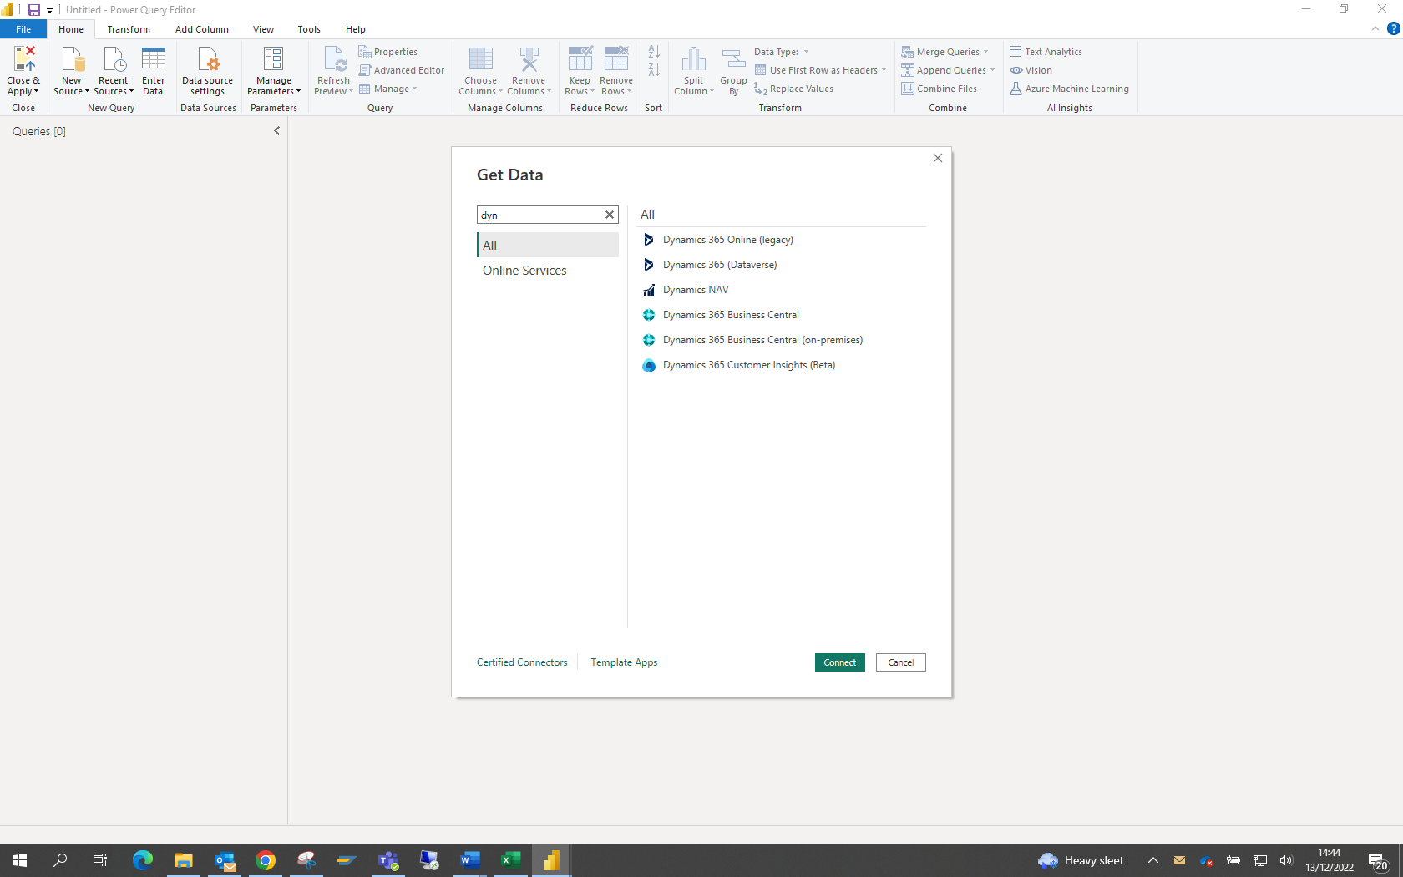

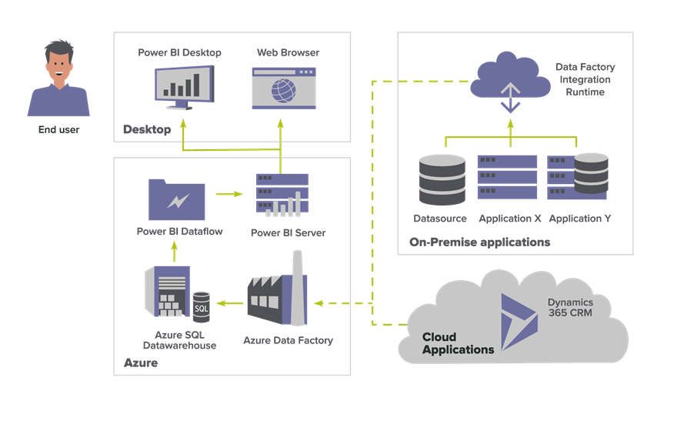

Power BI connects to many applications, below is a screenshot showing some sample sources:

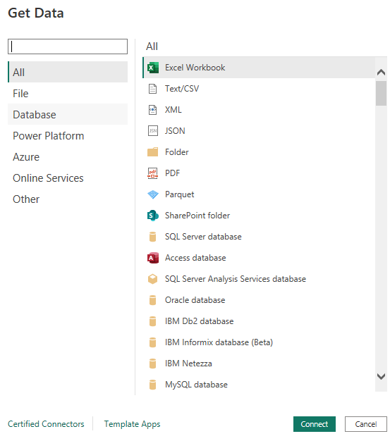

However, for the purposes of this project, the obtained sample set was loaded directly into Microsoft Power BI as per the Power BI Implementation section of Part 2 of this report.

## Process Flow

Business process flows are used as a guide for people, leading them through the process which has been defined by the organisation. Process flows reduce the need for training, as the process can guide people. A set of stages and steps make up the flow and are displayed at the top of the user form (as per examples below).

Some of the key business process flows are shown below:

* Sales Process Lifecycle
* Lead to Closed sale in CRM
* PTP (Procure to Pay) process in Financials & Operations
* OTC (Order to Cash) process in Financials & Operations

Dynamics 365 has prebuilt business logic, as seen in the sales process lifecycle:

1. Lead



1. Account
2. Contact
3. Opportunity
4. Product Catalog
5. Quote
6. Order
7. Invoice

Sample Process Flow for CRM – this is the pipeline used for converting a Lead to a Closed Sale:

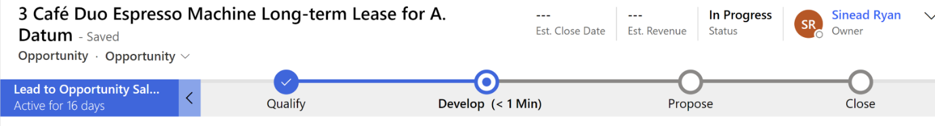

This flow shows the workflow from opportunity to sale. Dynamics 365 enables the creation of flows & business rules through the visual designer.

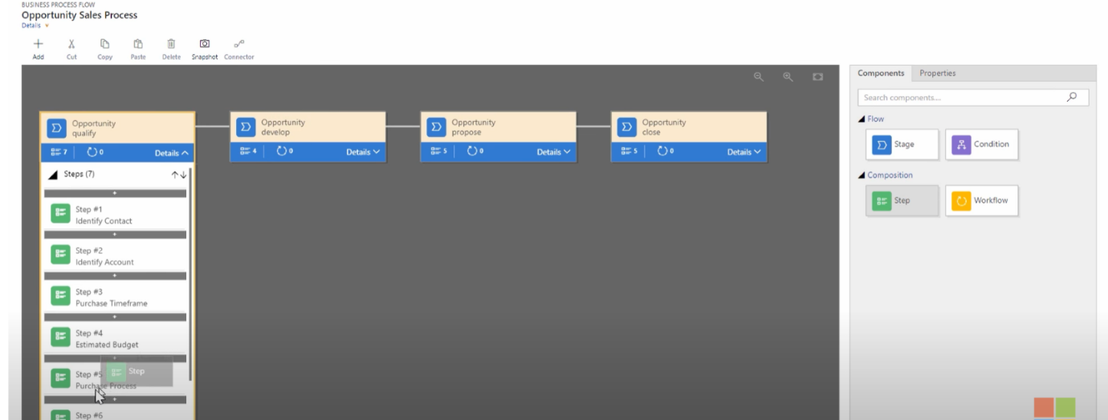

The following is a flow using a business condition prior to the account being generated:

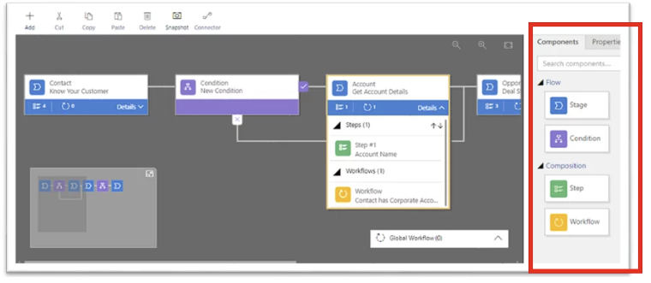

There is also the functionality to drag & drop business rules into the flow:

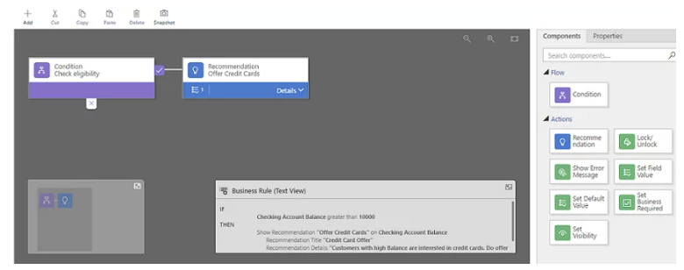

Finance and Operations Module:

As the finance & operations module is a full ERP system there are numerous process flows involved. 2 of the most basic finance functions would be PTP (Procure to Pay) and OTC (order to Cash). The standard process flows for these are as follows:

PTP:

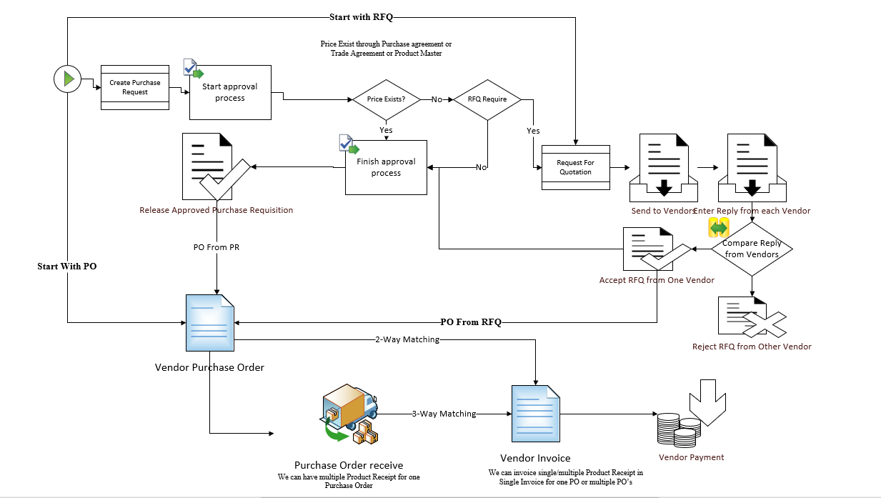

OTC:

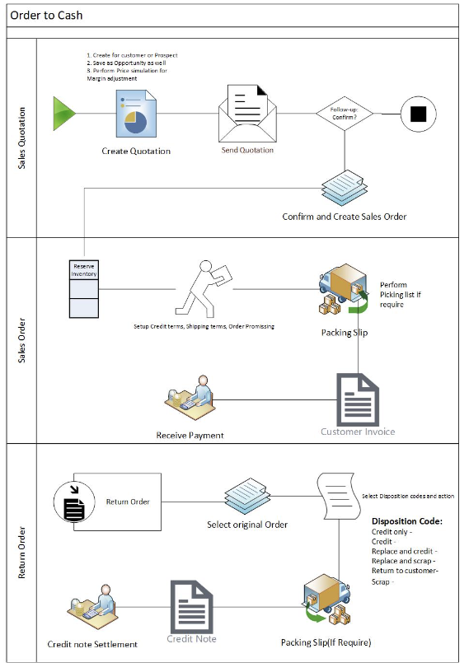

## Customer Interaction

Although not in scope for this iteration of the project implementation, Dynamics 365 offers a ‘Customer Service’ module. This allows for customer engagement and customer self-service to view their own cases. Support forums are available for customers to engage and provide advice to others. Social channels are also available to the customer here. Customers can connect with virtual agents which can help diagnose & fix certain issues. From here the customer can be connected to a human agent if required.

However, even though turning on customer interaction is out of scope for this project, the agents will still have visibility to the Timeline activities within each customer. This allows visibility of all previous interactions with the customer. It also allows the agent to view all related customer information, for example the linked/related accounts, contacts etc.

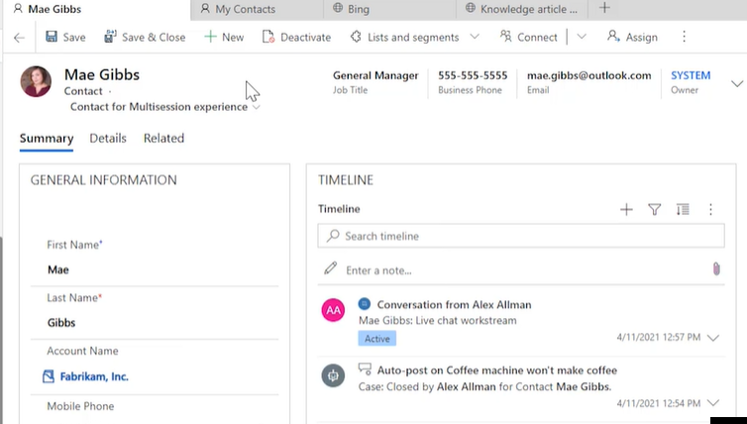

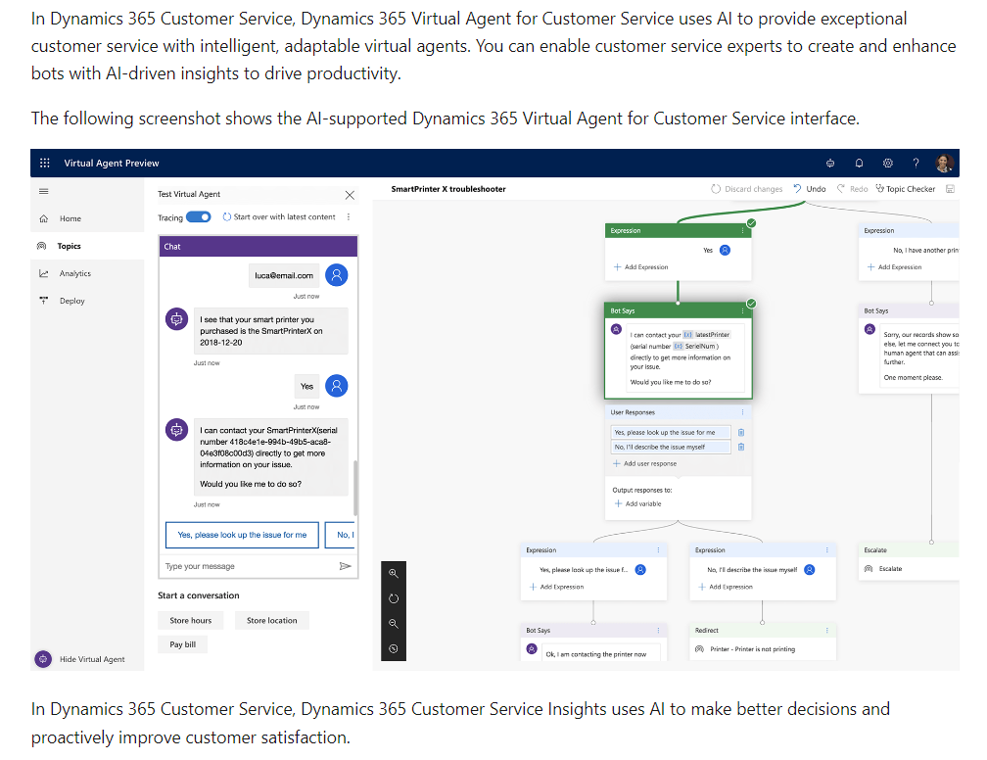

Part 2 (a): Project Implementation

# Development Process

## Overview

The deployment, installation, and conversion of the information system into a functioning system are all included in the implementation plan. The implementation plan includes a summary of the system, a brief description of the key tasks involved, the overall resources required to support the endeavour (such as hardware, software, facilities, materials, and staff), and any site-specific implementation requirements. The final version of the plan is delivered in the Integration and Test Phase and is used as guidance during the Implementation Phase. The plan is created during the Design Phase and updated during the Development Phase. The Implementation Plan's structure is depicted in the outline.

## Introduction

This project is going to follow the basic project implementation process:

* Initiate – the project specification document details
* Implement – design, build and test the solution
* Prepare – prepare to go live
* Operate – production environment now live.

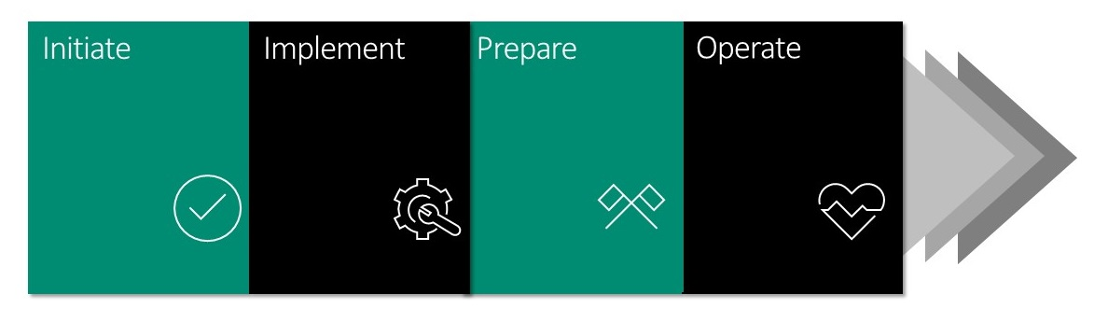

# Final Architecture

Following mapping the requirements it was decided that the out of the box solution would work best for ABC Ltd. There is no requirement for configurations or customizations.

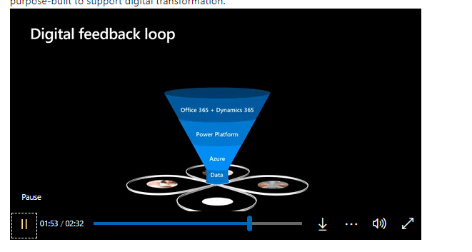

Implementation Methodologies:

There are both waterfall and agile (iterative) methodologies available for implementation of the project. The agile method works best for this type of project as it allowed for an iterative approach.

Waterfall:

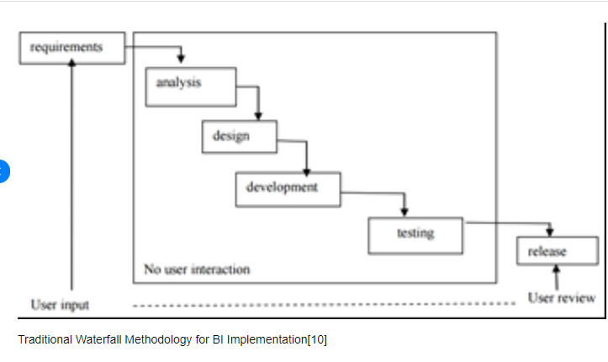

Each new step feeds into the next step in a way that one can’t begin without the previous one being complete.

1. Requirements and Planning
2. Design
3. Implementation
4. Verification/Testing
5. Maintenance

The waterfall methodology is useful for the customer when trying to estimate the duration and cost of a project. However, usually, as a project progresses additional requirements are typically identified. Agile keeps the scope fluid between ‘sprints. The scope of each sprint can be agreed, and any further requests can be put into the next sprint/ phase of the project.

Agile:

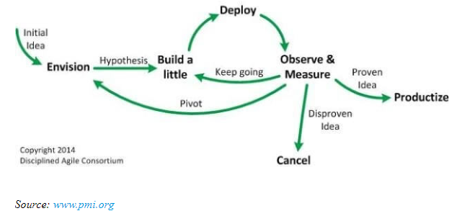

The key concepts of Agile implantation are as follows:

* Builds software incrementally instead of trying to deliver the entire product at the end.
* Concept: light documentation – does not need to be heavily mapped out. Explain the initial architecture, consider the practical aspects of delivering the project, and identify the prioritization between them.
* Inception: critical implementation state where you engage the stakeholder. Determine BI funding, identify key business needs and requirements. Understand the expected delivery routes – dashboards, reports etc.
* Prioritize the key business requirements with time & budget constraints in mind. A frequency v’s difficulty quadrant could be used to identify the priorities.
* Investigate the BI options and chose & implement them.
* Construct Iterations: this stage may need to be cycled through a few times before moving into production. Involve stakeholders, collaboratively develop reports, utilize JIT (Just in time) modelling (identify the issues, explore, then carry on)
* Test BI in a small group, then deploy.
* Transition/Release: release the previous iteration into production, return to iteration, then return to production with the changes. During transition: finalize testing, finalize documentation, release to a sub-group, deploy to production (once staff are trained)
* Production: operate and support the system, dashboards & reports. Identify defects and enhancements

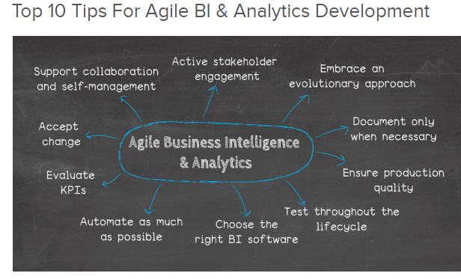

## System Architecture

A typical business intelligence architecture will consist of the extract, transform, and load (ETL) process to data warehouses and data marts. From there it will be reported or where it will be organised and made accessible through an OLAP analysis. Therefore, it is essential to gather and incorporate all available data from the data sources and into the BI databases and data marts. The mart is an essential part of any business as it is a subset of the whole organisation’s data warehouse. The output will then result in analytical methods as well as mathematical models. Examples of this would include data mining, exploratory analysis (EDA), and optimisation models. A more thorough explanation of the architecture is described in the hierarchical diagram below. Data exploration can be considered passive as they demand an initial hypothesis and definitions for the removal of data from the decision-makers. Data mining is only described as part of the process according to many sources and is used to support BI analysis, in other words, to obtain intelligence from the data. The most fundamental processes for data mining include classification, prediction, and association rules. Last but one is the optimisation layer of the hierarchy which checks for the most optimal solution from various amounts of alternatives. Decisions are the final layer of the hierarchy, and the decisions will ultimately rest with the decision-makers regardless of if there are effective BI methodologies in place.

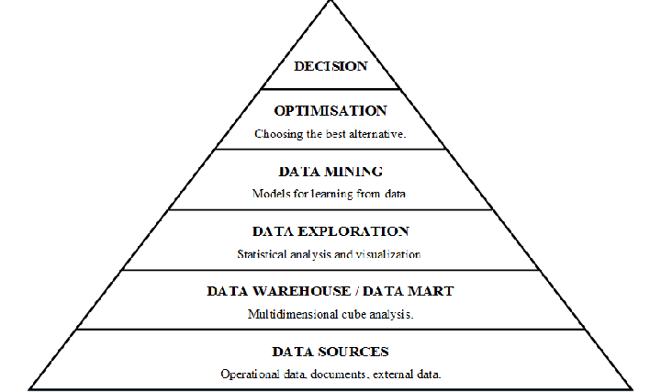

(Source: Kopcekova, A. et al 2013)

Before we submit a plan for knowledge discovery for the hierarchical process a few further phases should be carried out.

* Data analysis at all levels of the hierarchy
* Verification and validation in line with international guidelines for the data storage design.
* Heterogenous data is transformed into a single arrangement, which is granted by the application of the data storage.

These three stages are a prerequisite for achieving the defined intention i.e., to use the data warehouses for the process control by using the pyramid model.

### Finance & Operations applications architecture:

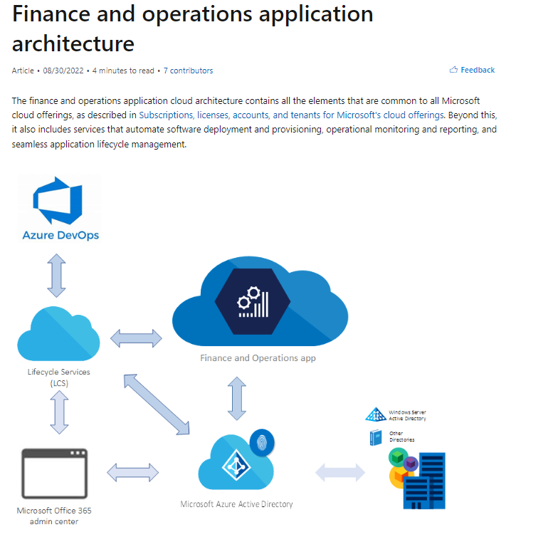

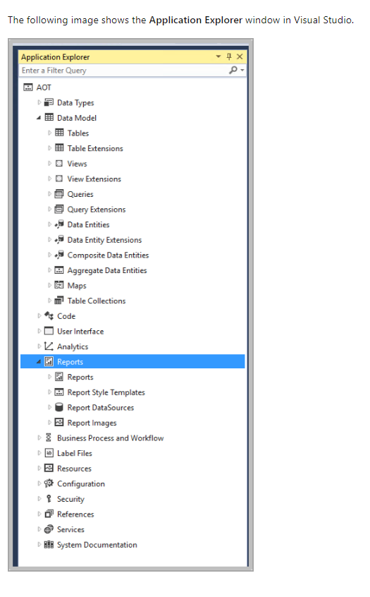

# Process control features.

## Discovery

The analysis of business events recorded in event logs to discover process, control data, organizational and social structures.

* Understanding the process
* Value of process
* Identification of process components, influences, and cost

## Analysis

Allows users to analyse completed process executions from both business and IT perspective.

* Finished Vs Active processes
* Transparency of a workflow
* Effective benchmarking

## Prediction

* Derives prediction models and apply such models to running processes, to identify in particular the possibility of exceptions or undesired behaviour

## Monitoring

* Monitors and analyses running processes instances, and informs the user of unusual or undesired situations

## Optimization (Improvement)

Identifies areas of improvement in business process definitions and in the assignment of resources and services to work activities.

# Operations and Benefits of the solution

Dynamics 365 offers solutions to suit each individual business needs, rather than a ‘one-size fits all’ solution. There are several modules available to the organization to implement, as and when required.

The modules currently offered are:

**Sales – manages an effective sales process within the company. Lead to sales pipeline

Business Central – ERP solution for smaller companies

Field Service – end to end service experience

Customer Service – effective customer engagement

Project Automation – optimizes project management

Supply Chain Management – life cycle of production

Commerce – suitable for retailers

Human Resources

Marketing – turns prospects into business relationships

**Finance and Operations – ERP software as a service (SaaS) – used for companies with over 500 employees

With so many modules available it was decided to focus on the Sales module accompanied by the Finance and Operations module. These will be added to in time as the business grows and experiences the benefits of implementing the solution.

The key benefits identified with this solution is that Dynamics 365 easily integrates with other Microsoft products. The solution provided built in analytics which is a huge driver for ABC Ltd when it comes to implementing a BI Solution. The scalability of the solution is very appealing. ABC Ltd is aware that there are untold benefits of implementing further modules, but rather than make the project scope overwhelming at this point in time, it was decided that a phased approach would be best.

Part 2 (b): Power BI implementation

# Microsoft Power BI

The source data ‘US Regional Sales Data’ was obtained from data.world.com. This data was loaded into Power BI using the ‘Transform Data’ option. Using this option allows the user to validate the data types of each column prior to loading the data into the data model.

The tables detailed in Appendix 1 were validated and loaded. The data types were validated to ensure that date type was applied to relevant columns, whole number where required and of course decimal number. There are no strings or boleans in this dataset.

Star schema modelling was used in the data model below. That is the transactional data is stored in the fact table (sales), with all the lookup (dimension) tables joined accordingly. The joins here all have the sales table on the ‘many’ side of the relationship.

There are different dates columns available in the Sales table, so a dates table was created. Again, using the ‘Transform’ option; New Source; Blank Query, the code in Appendix 2 was entered to generate the dates table, using a parameter query.

Once all the tables were loaded, the data model was checked. Power BI is quite intuitive with identifying relationships/joins between tables. However, these should always be checked and verified. The ‘Delivery Date’ column from the ‘Sales’ Table was identified as the date for reporting requirements. This field was therefore joined to the dates table. This of course can be changed at any time by revisiting the model and changing the join to the required date from the ‘Sales’ table. However, there can only be one ‘active’ join.

The data model is as follows:

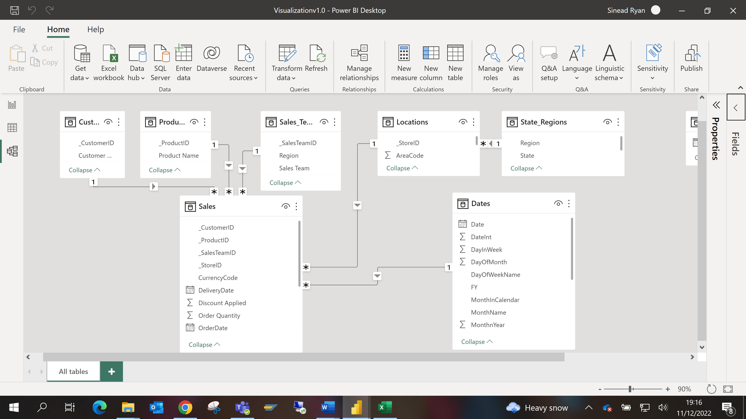

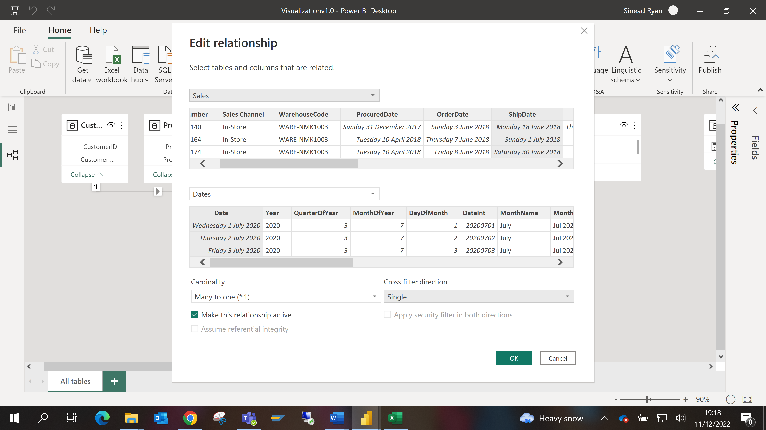

Now that the model and relationships have been established the reporting requirements must be fulfilled.

From the project requirement document the reporting requirements were established. Namely to monitor the following KPI’s:

* Revenue by Location/Region
* Sales Trends (Revenue based)
* Revenue by Product
* Margin Analysis
* Volume of Customers by Sales Channel
* Volume of Customers by location
* Order quantities by location

The data would be available for these KPI’s in Dynamics 365, Power BI was used to generate all of the required dashboards. To this effect, some key measures were created using DAX formulae including:

Revenue – using SUMX (iterative) function on unit price and quantity

Total Costs – using SUMX function on unit cost and quantity

Margin using the Revenue and COGS (Cost of Goods Sold) key measures

These key measures were then added to a ‘key measures’ table. Using these key measures allowed for the generation of required reports and dashboards. These visualizations are presented at executive level but can be drilled into for further details.

The following Dashboards were generated:

[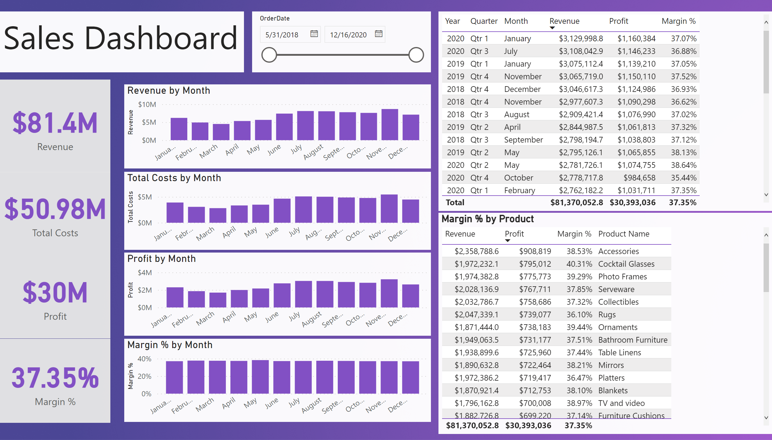](https://app.powerbi.com/groups/me/reports/6b2f544c-319b-4d49-8ae5-699103a626b2/?pbi_source=PowerPoint)

[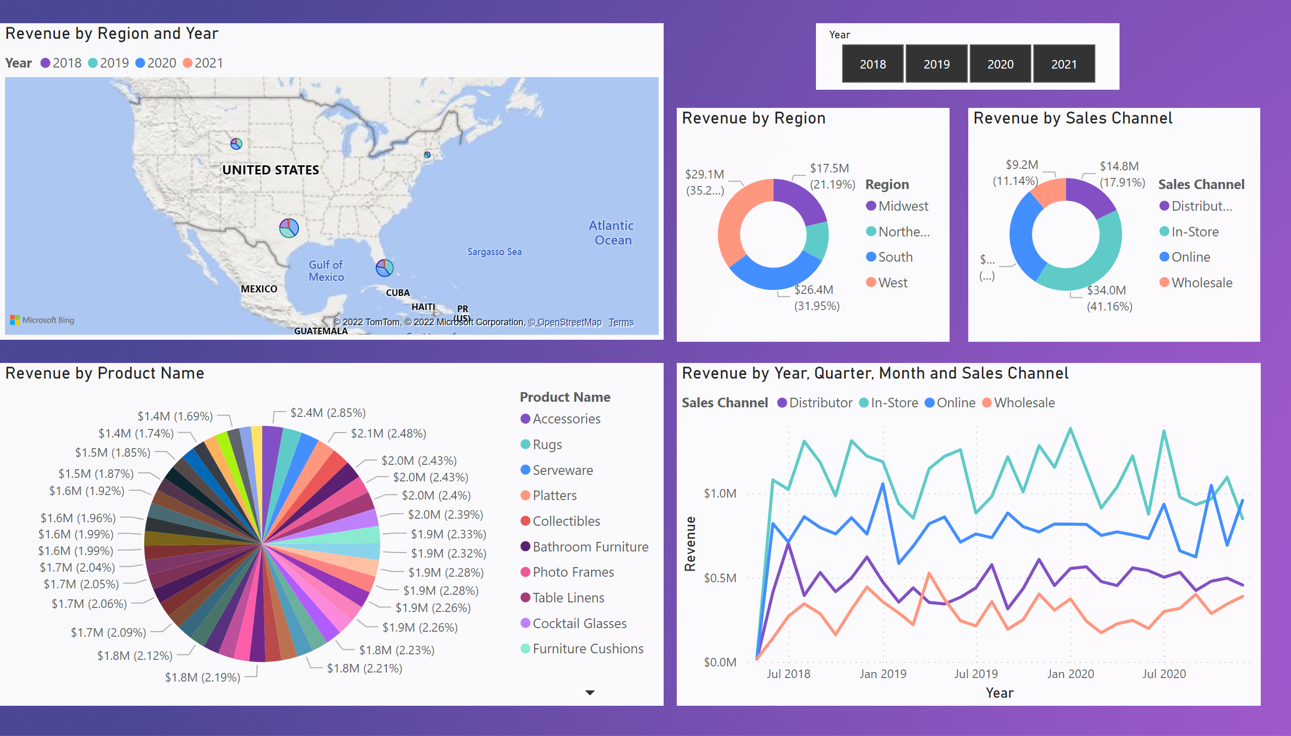](https://app.powerbi.com/groups/me/reports/6b2f544c-319b-4d49-8ae5-699103a626b2/?pbi_source=PowerPoint)

[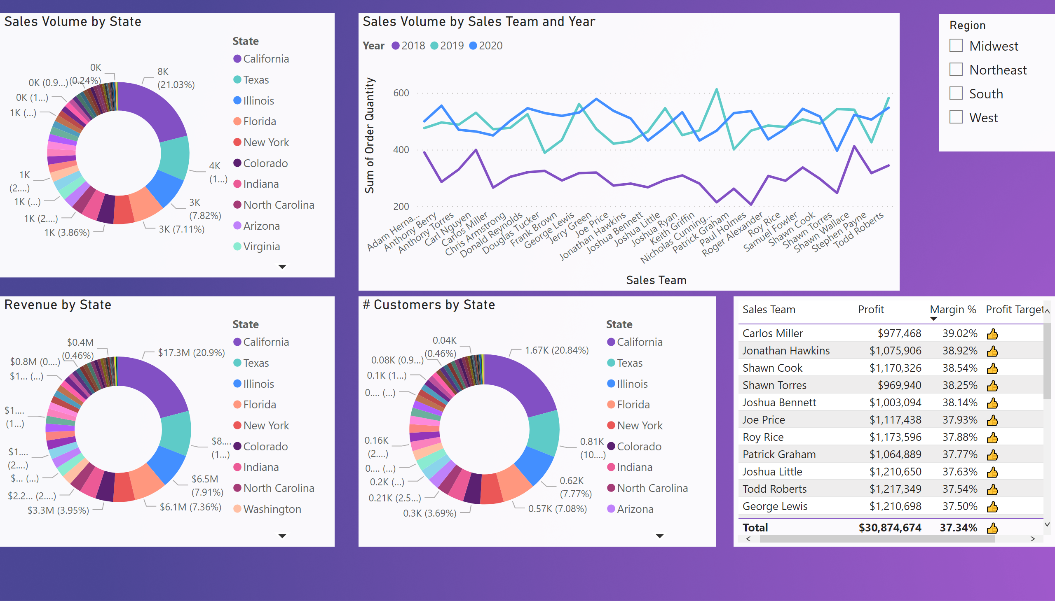](https://app.powerbi.com/groups/me/reports/6b2f544c-319b-4d49-8ae5-699103a626b2/?pbi_source=PowerPoint)

[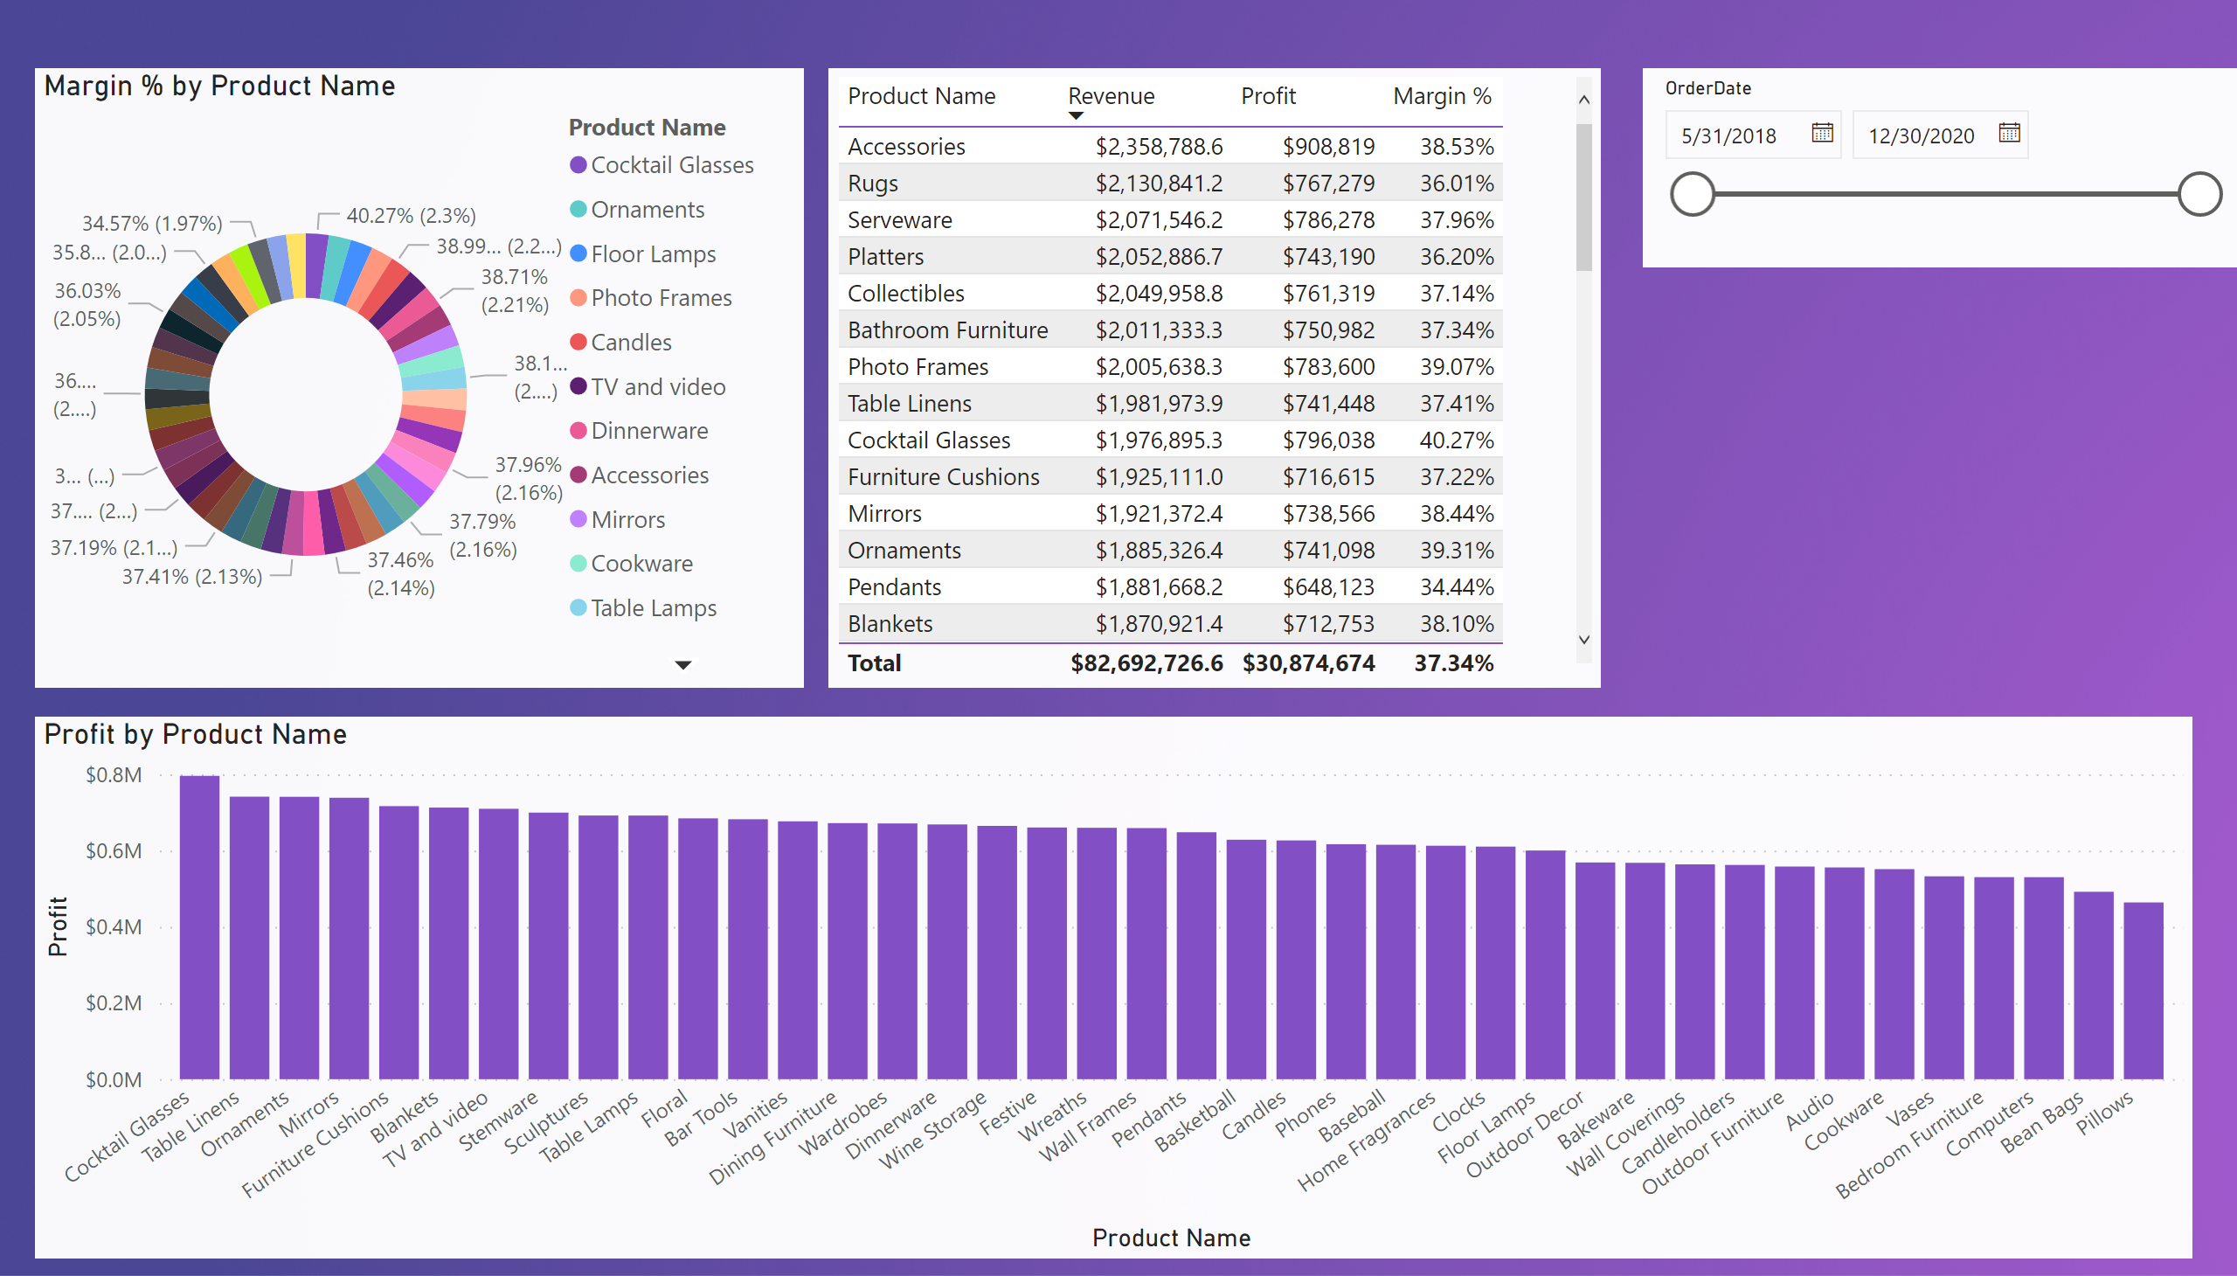](https://app.powerbi.com/groups/me/reports/6b2f544c-319b-4d49-8ae5-699103a626b2/?pbi_source=PowerPoint)

Part 2 (C) – Business insights

# Business Insights

### Revenue by Sales Channel

From the analysis it is evident that the Wholesale channel is underperforming when compared to the other channels. On average is it generating only 11.14% of revenues to date. This is quite a poor performance when compared to the In-store channel which has generated 41.16% of all revenues to date. This is quite surprising considering the negative impact the recent Covid pandemic would have had on In-store sales. It would have been expected that the online sales would have spiked but are only accountable for just under 30% of revenue generated. The only real spike visible, where online sales surpassed in-store, is in Q4 2020.

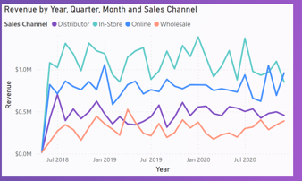

### Margin Analysis

ABC Ltd is eager to maintain profit margins. However as stated earlier they need to be mindful of the competitors. Outdoor Furniture is attracting the lowest margin at 34.19%, whilst cocktail glasses are generating a whopping 40.31%. Cocktail glasses are in the top 10 revenue-generating products and unsurprisingly the 2nd most profitable item. ABC Ltd only has 3 products generating profit margins less than 35%. This is even with various discounts applied. Perhaps if they are to become serious about competing in this market, they might need to consider reducing the margins on some of their products, and even introduce some ‘loss leaders’ if necessary.

### Regional Analysis

It is clear from the analysis that the north-east region is not performing as well as all other regions.

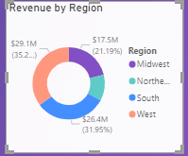

It has generated $9MM in revenue compared to $29MM generated in the West. It appears that New York is the state in the North East which is keeping the region going:

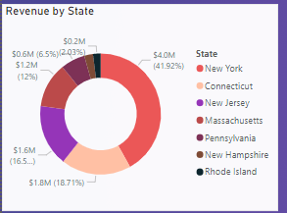

ABC Ltd should consider some marketing strategies for this region to try to increase these sales.

### Conclusion

ABC Ltd appears to be a very profitable organization. There are very few KPI’s which would cause concern at this point in time. Considering they are a relatively new company, competing in a very strong market, the results are very impressive. It is the correct decision to undertake this business intelligence implementation at this time. It will allow them to reap the benefits of all that Dynamics 365 & Power BI have to offer, while the company is still in its infancy and trading under such good conditions. It looks like the only way it up for this company!

Part 2 (d) – Team Reflection

Although we had our challenges with only two members, we both worked very well together. This was mainly due to being in regular contact as well as having regular meetings on MS Teams. As we were both conscious of the deadline Sinead was instrumental in organising the objectives of the assignment as well as identifying the terms needed to make the assignment a success. Splitting the complex tasks helped both of us improve our skills from the module. Furthermore, we both collaborated extremely well and from a professional standpoint, it will no doubt help us communicate more effectively. Although there was some confusion about how to implement the business intelligence suite, we both developed our ability to overcome challenges as we were both accountable to one another. An example of this was when Sinead developed the business intelligence suite and the modules we would use in Dynamics 365, it then gave Kieran the chance to implement the dashboard and provide details for the analysis of the business. Both of us were open to suggestions and were respectful of each other’s opinions which helped us complete the assignment efficiently and effectively.

# References

Luhn, H.P. A Business Intelligence System. IBM J. Res. Dev. 1958, 2, 314–319.

Vittoria Biagi and Angela Russo (2022) ‘Data Model Design to Support Data-Driven IT Governance Implementation’, *Technologies*, 10(106), p. 106.

Rick Sherman (2014) *Business Intelligence* *Guidebook : From Data Integration to Analytics*. Amsterdam: Morgan Kaufmann.

Kale, V. (2016) *Enhancing enterprise* *intelligence : leveraging ERP, CRM, SCM,* *PLM,* *BPM, and BI / Vivek Kale*. CRC Press.

JOVACO Solutions. 2022. Case Study: Make the Most of Your CRM Data with Microsoft Power BI - CRM Software Blog | Dynamics 365. [ONLINE] Available at: <https://www.crmsoftwareblog.com/2019/09/leverage-dynamics-365-crm-data-microsoft-power-bi/>. [Accessed 07 December 2022].

|  |
| --- |
| [Online]. Available: https://www.gartner.com/reviews/market/analytics-business-intelligence-platforms/compare/product/microsoft-power-bi-vs-qlik-sense-vs-tableau-desktop. [Accessed 20 November 2022]. |
| A. Meik, "Technology Advice," 27 June 2022. [Online]. Available: https://technologyadvice.com/blog/information-technology/dynamics-crm-vs-salesforce/. [Accessed 21 November 2022]. |
| C. Capistran, "Cobalt.net," 23 March 2022. [Online]. Available: https://www.cobalt.net/dynamics-365-vs-salesforce-price-and-value-comparison/#:~:text=But%20when%20you%20get%20to,(3X)%20cheaper%20than%20Salesforce.. [Accessed 22 November 2022].  <https://enkonix.com/blog/functional-requirements-vs-non-functional/>  Kopcekova, Alena & Kopcek, Michal & Tanuska, Pavol. (2013). Business Intelligence in Process Control. Research Papers Faculty of Materials Science and Technology Slovak University of Technology. 21. 10.2478/rput-2013-0039.  Pmi.org  <https://athena-solutions.com/essential-steps-in-the-data-integration-process/>  https://trial-njy9gb.trial.operations.dynamics.com/?mode=trial&cmp=DAT |